# CONSOLIDATED EXAM QUESTIONS

# PROPERTIES AND STRUCTURE OF MATERIALS

Contents

CONSOLIDATED EXAM QUESTIONS 1

PROPERTIES AND STRUCTURE OF MATERIALS 1

Syllabus 3

Properties of Metals – 4.1-4.4 5

2017 S1 5

2017 S2 6

2020 S1 6

2020 S2 6

2023 S1 6

2023 S2 6

Ionic Compounds – 5.1-5.5 7

2017 S1 7

2017 S2 7

2020 S1 8

2020 S2 8

2023 S1 8

2023 S2 8

Properties of Non Metallic Substances – 6.1-6.2 9

2017 S1 9

2017 S2 9

2020 S1 9

2020 S2 10

2023 S1 11

2023 S2 11

Hydrocarbons – 7.1-8.4 12

2017 S1 12

2017 S2 15

2020 S1 20

2020 S2 28

2023 S1 29

2023 S2 29

Nanomaterials – 1.2 30

2017 S1 30

2017 S2 31

2020 S1 31

2020 S2 31

2023 S1 31

2023 S2 31

Other Materials and Separation Techniques – 1.1, 1.3 32

2017 S1 32

2017 S2 34

2020 S1 35

2020 S2 39

2023 S1 41

2023 S2 41

# Syllabus

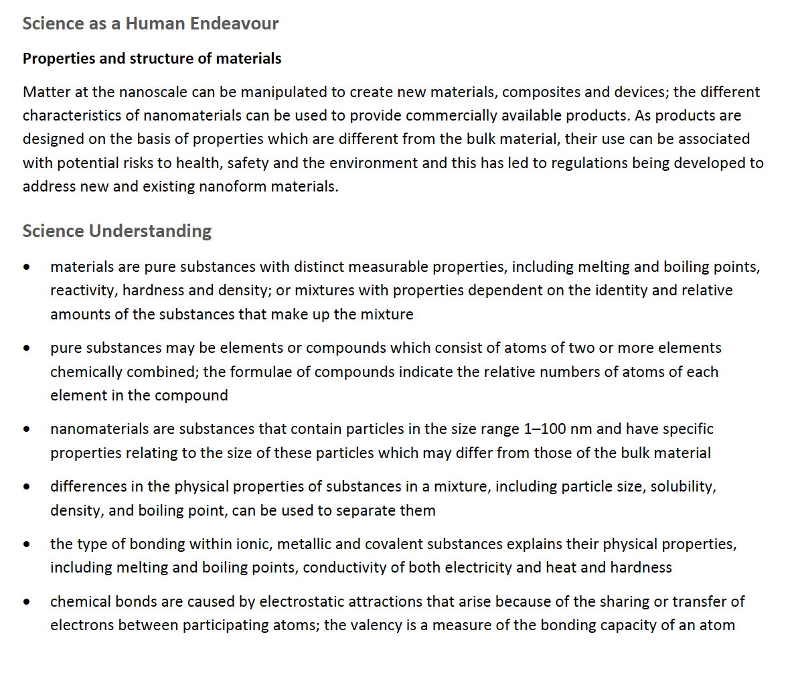

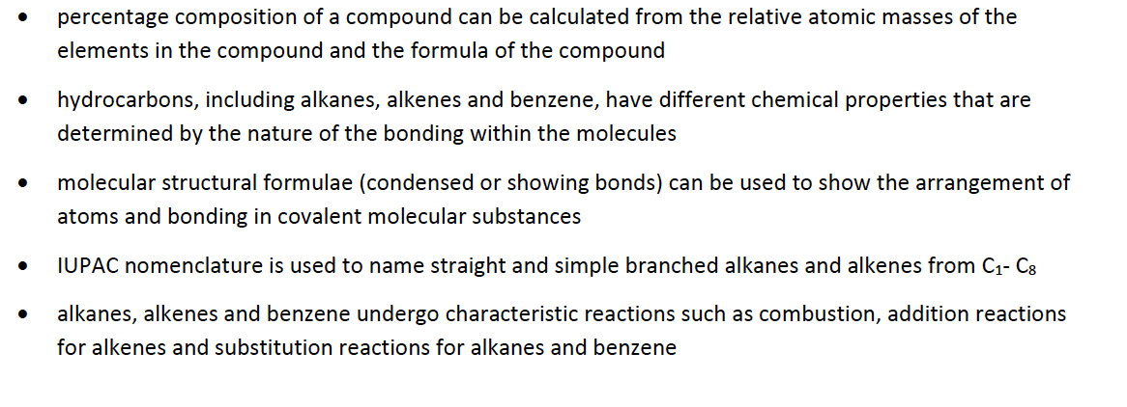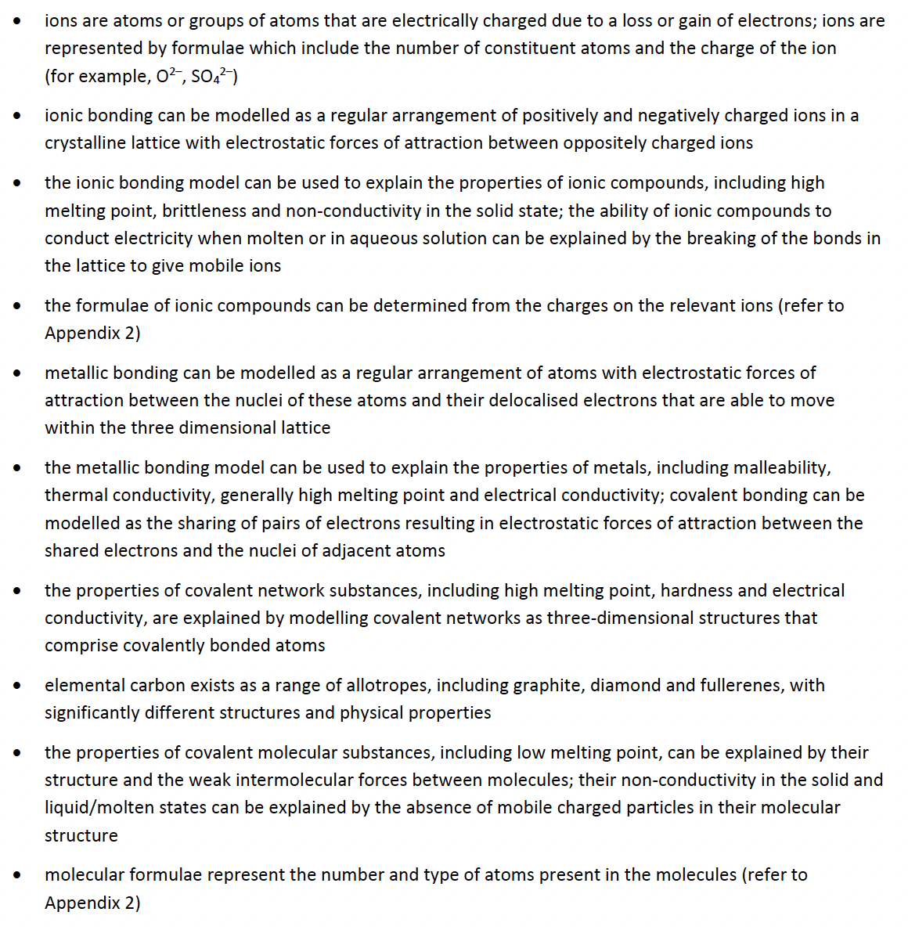

# Properties of Metals – 4.1-4.4

## 2017 S1

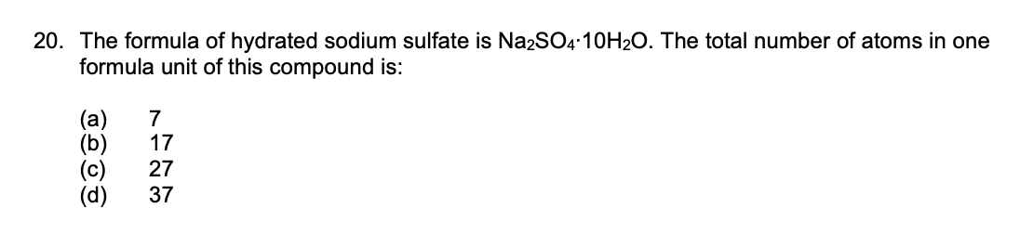

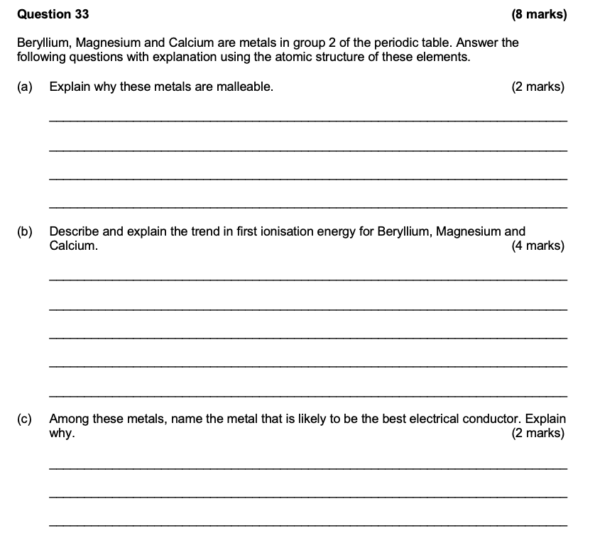

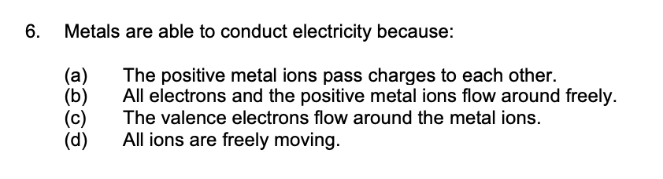

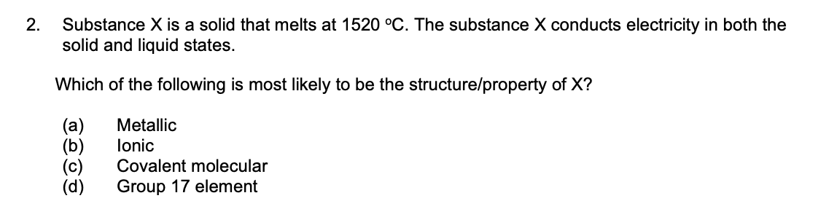

## 2017 S2

## 2020 S1

## 2020 S2

## 2023 S1

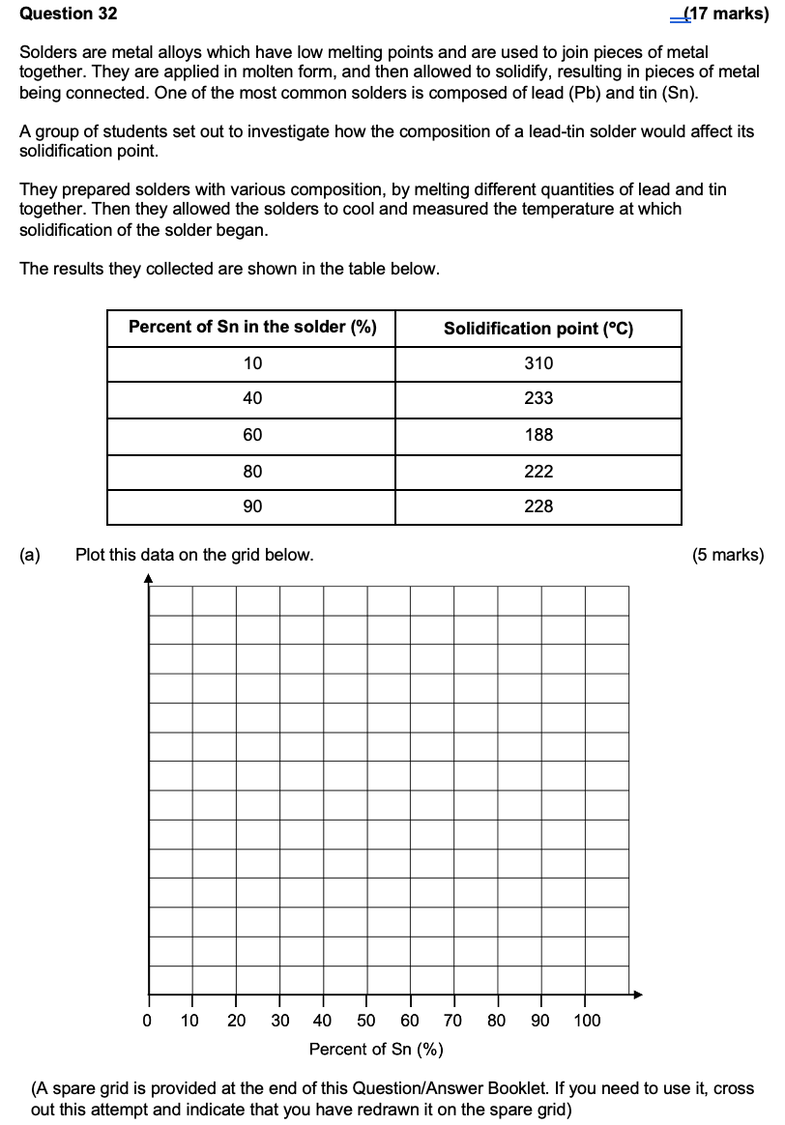

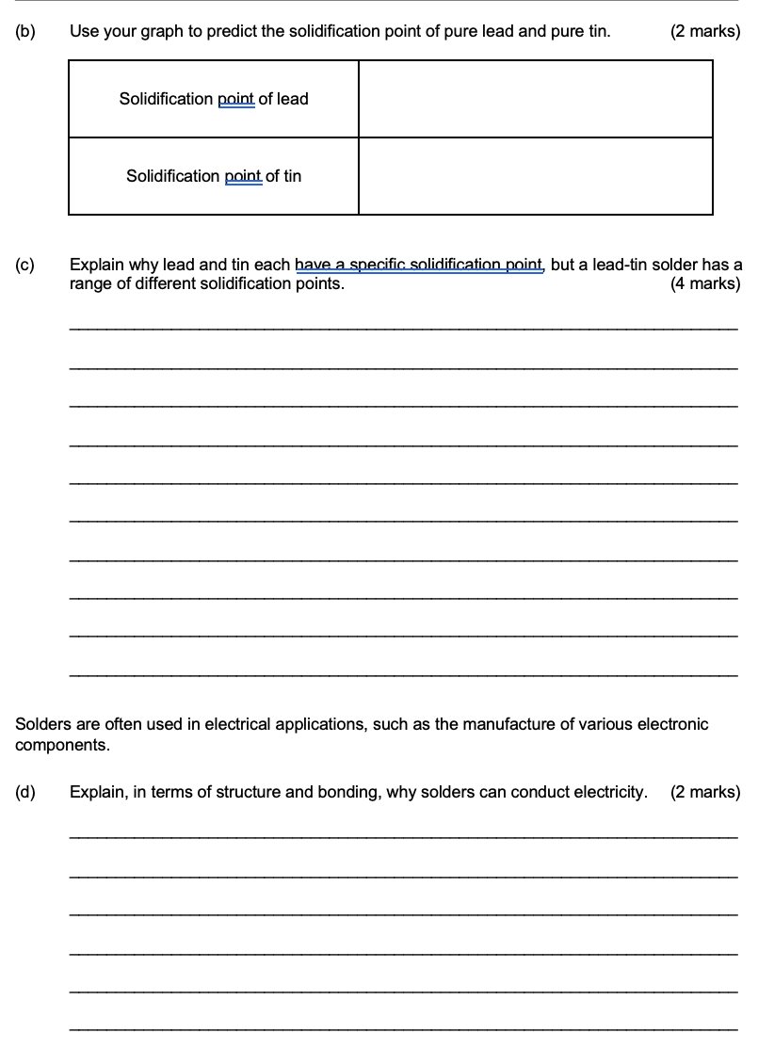

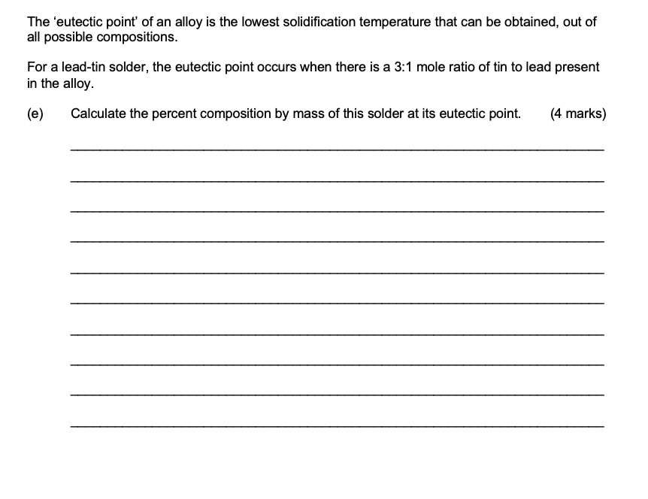

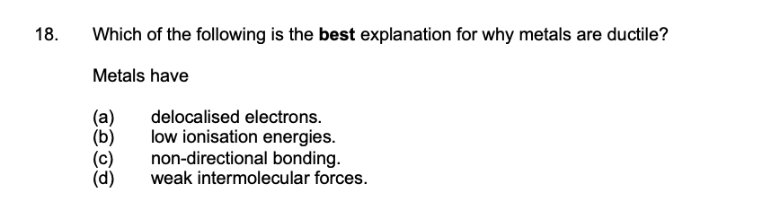

## 

## 2023 S2

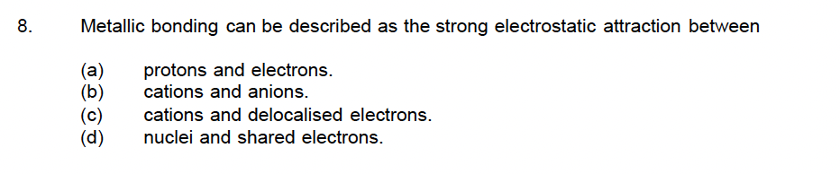

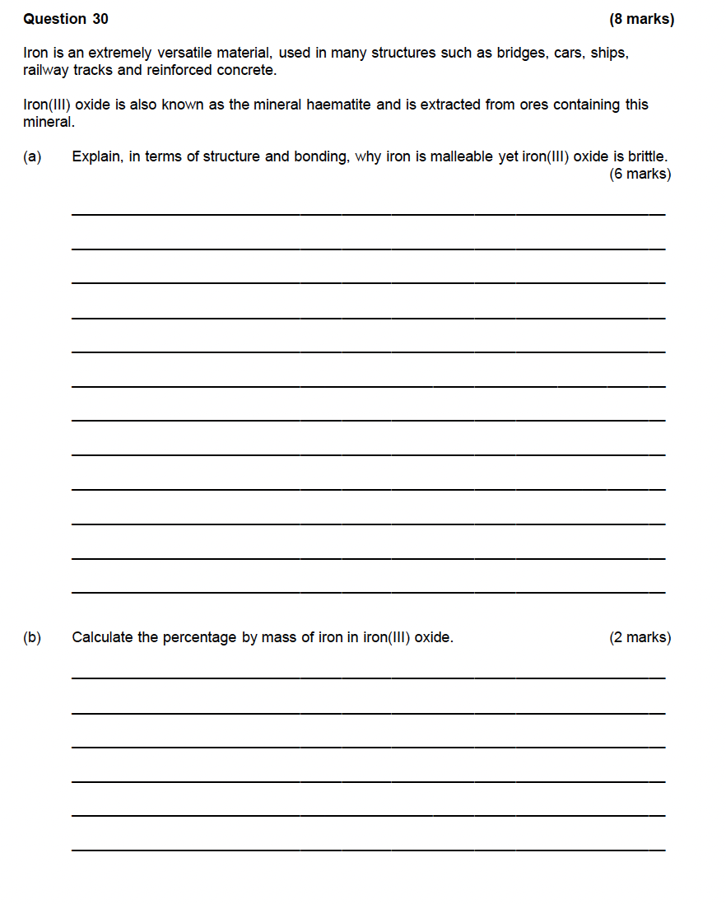

# Ionic Compounds – 5.1-5.5

## 2017 S1

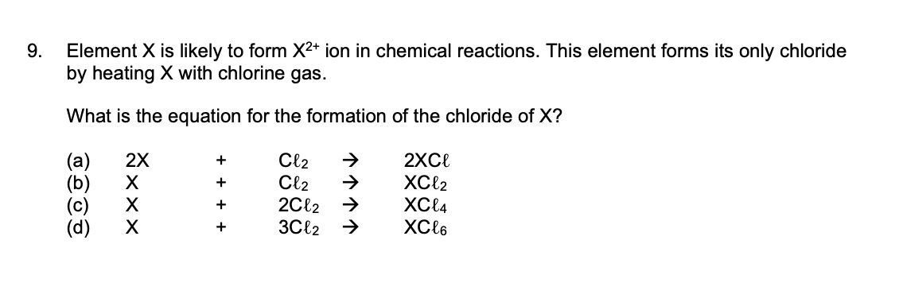

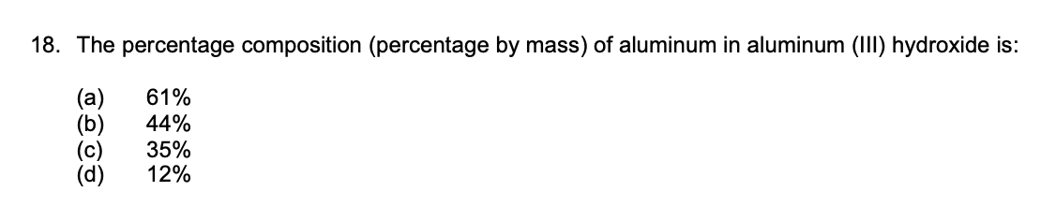

## 2017 S2

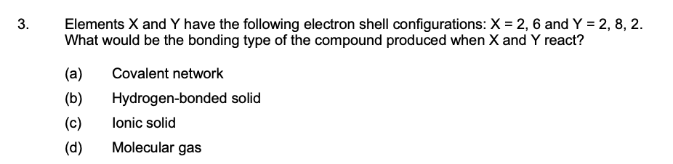

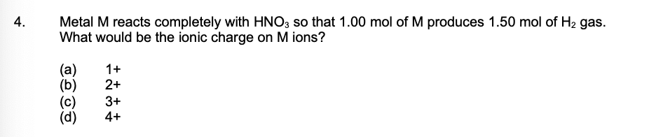

## 2020 S1

## 2020 S2

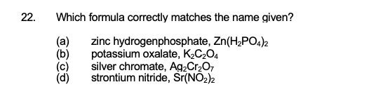

## 2023 S1

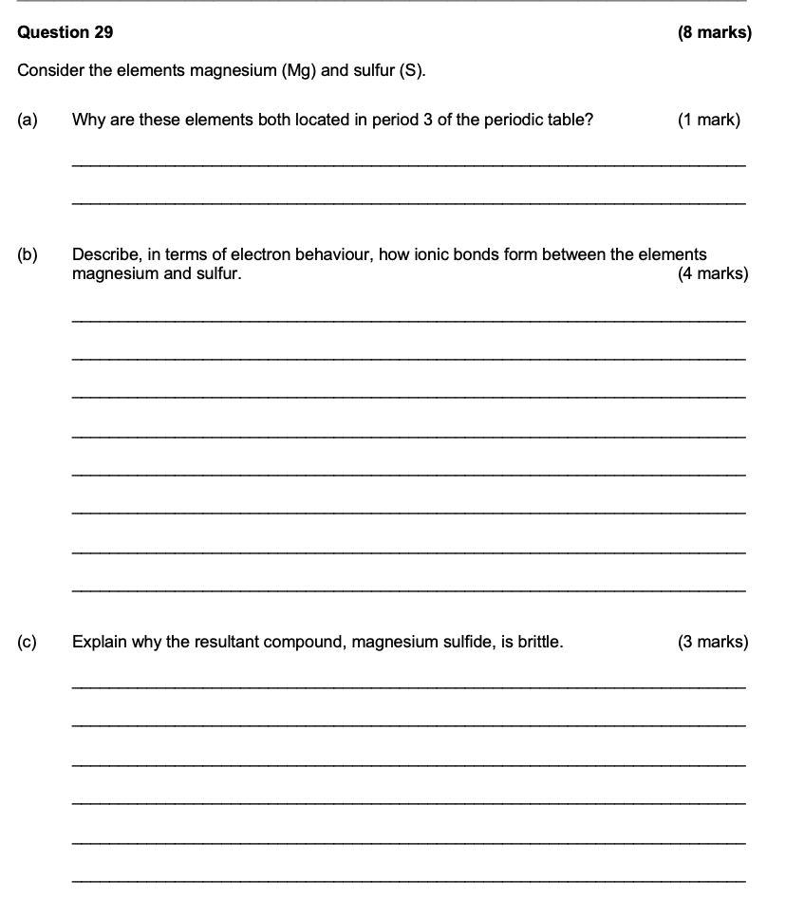

## 2023 S2

# Properties of Non Metallic Substances – 6.1-6.2

## 2017 S1

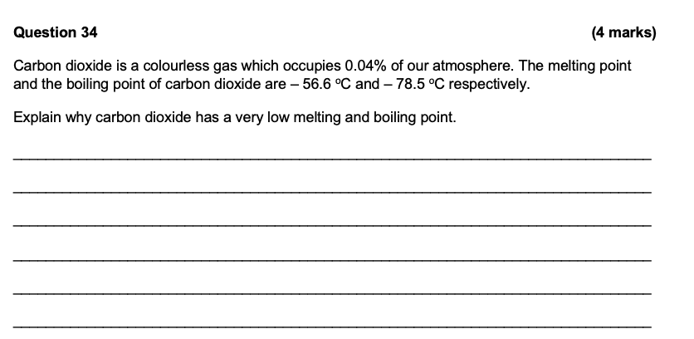

## 2017 S2

## 2020 S1

## 2020 S2

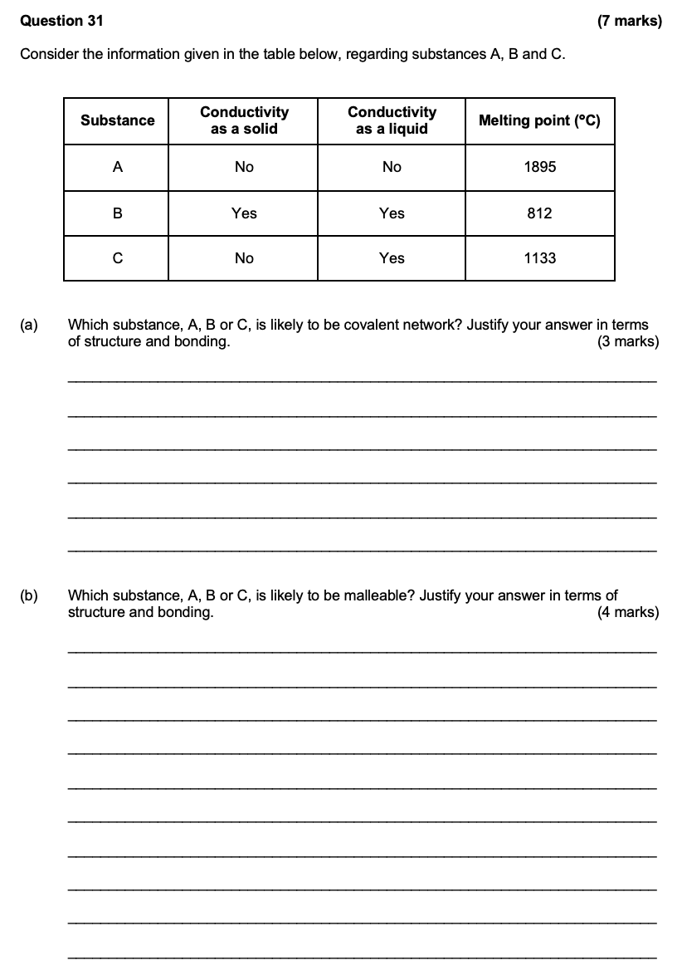

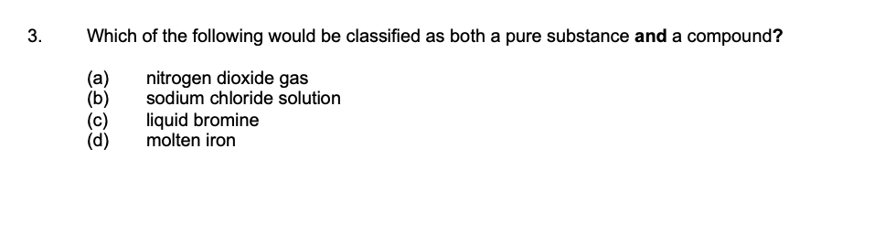

## 2023 S1

## 2023 S2

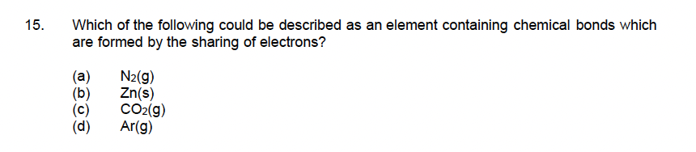

# Hydrocarbons – 7.1-8.4

## 2017 S1

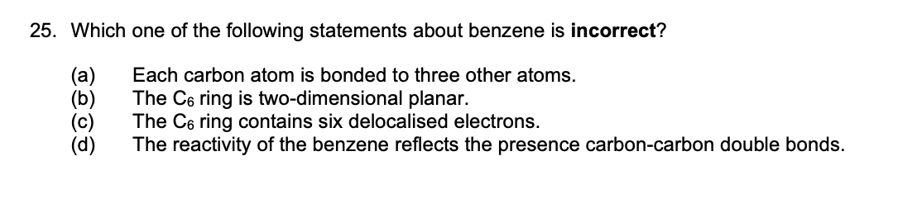

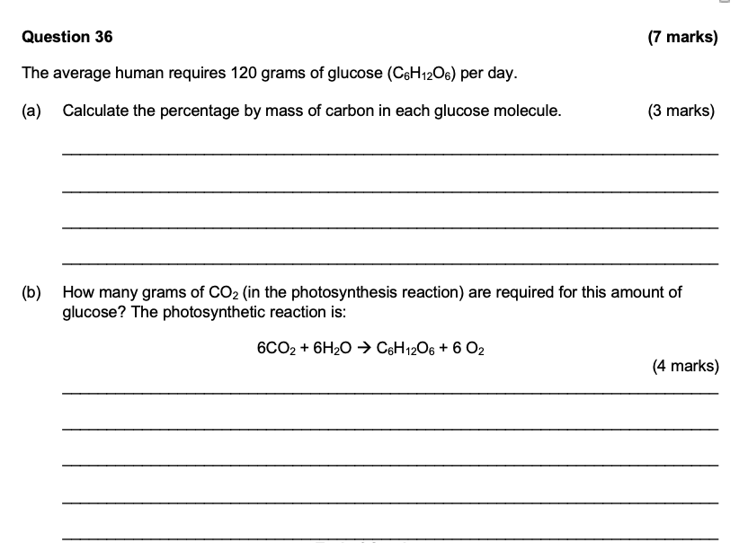

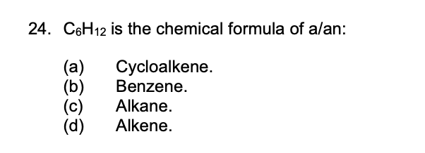

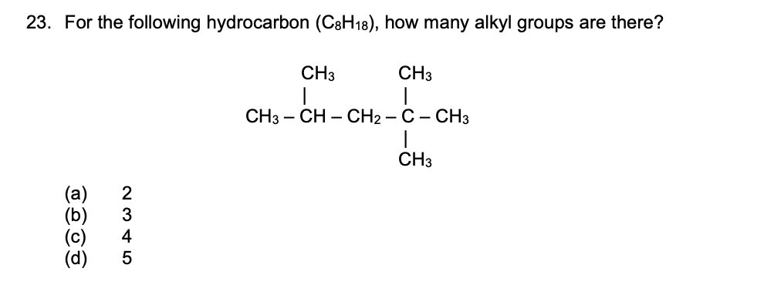

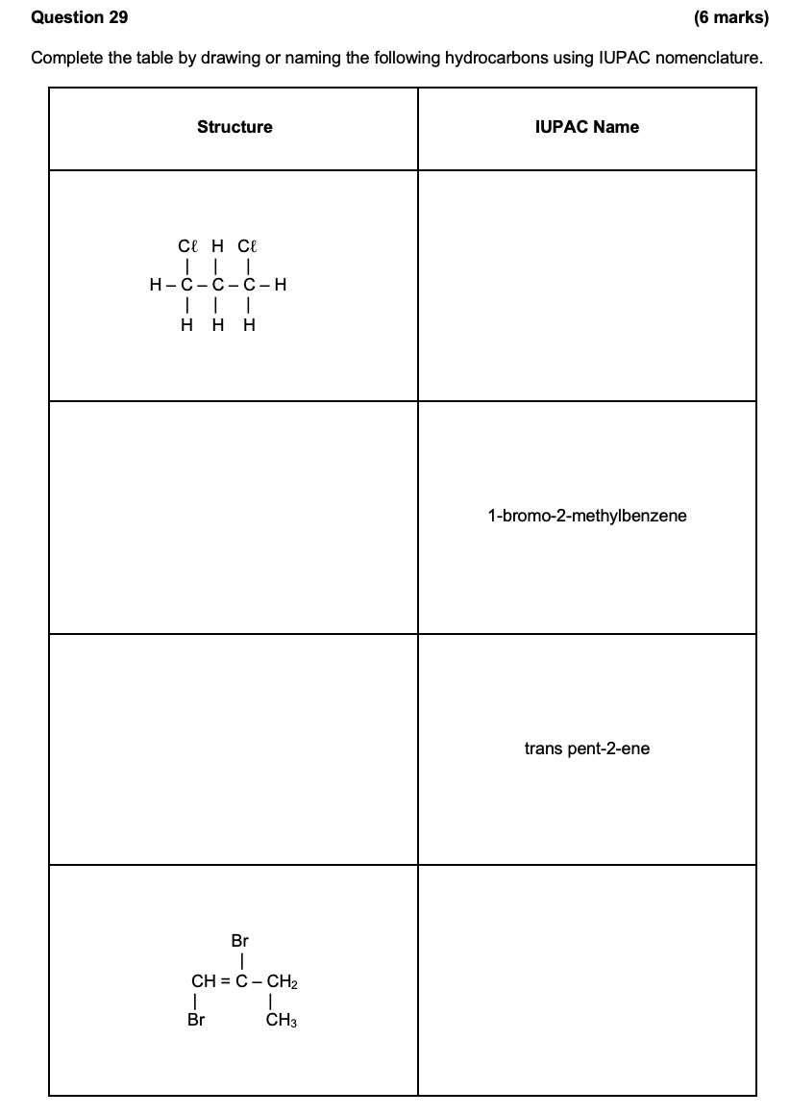

## 2017 S2

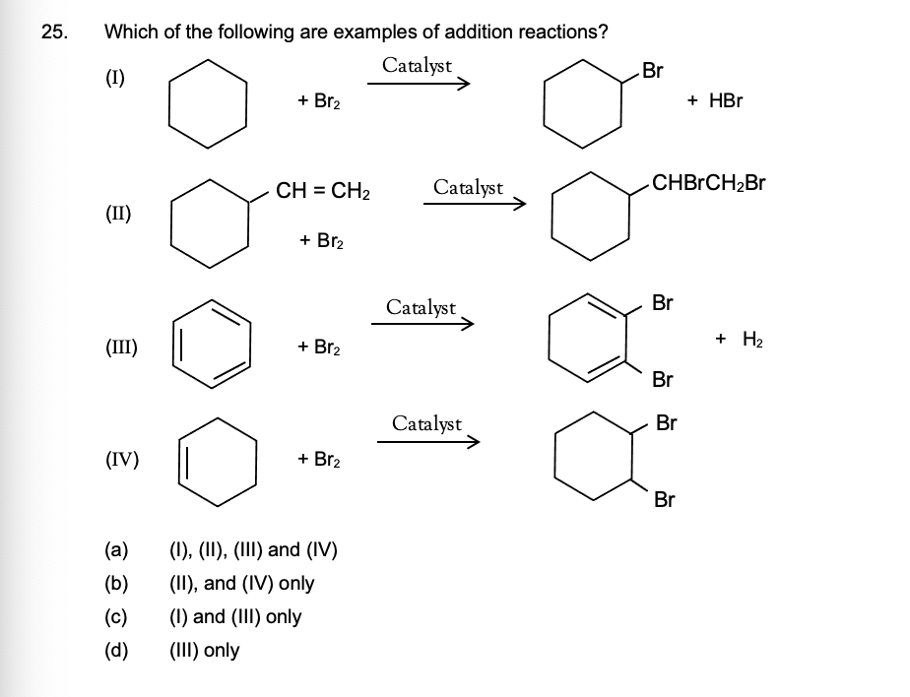

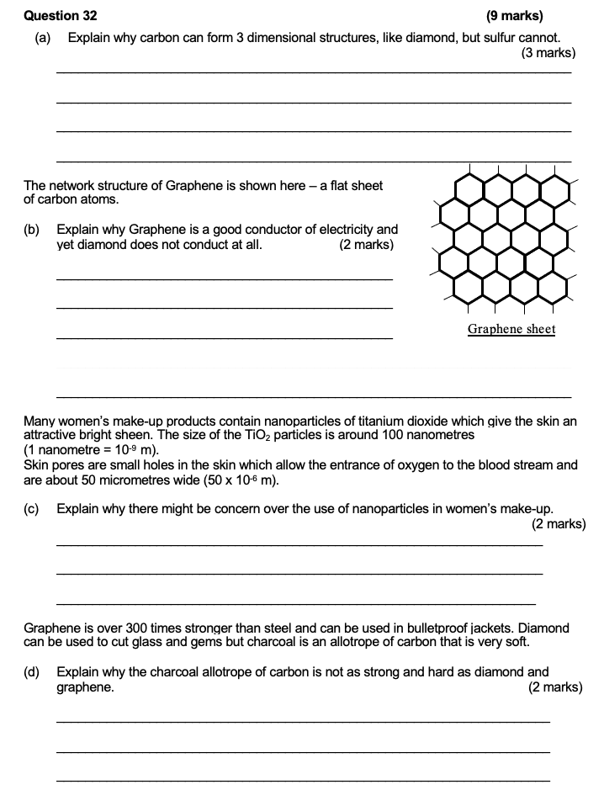

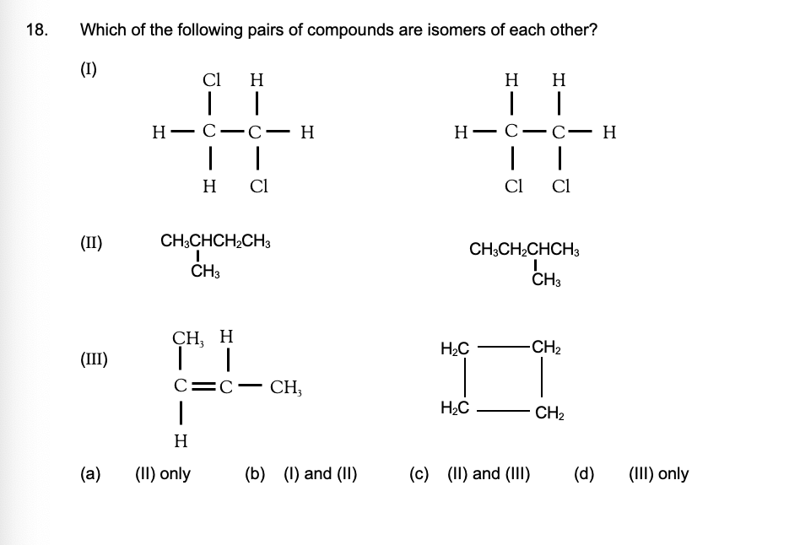

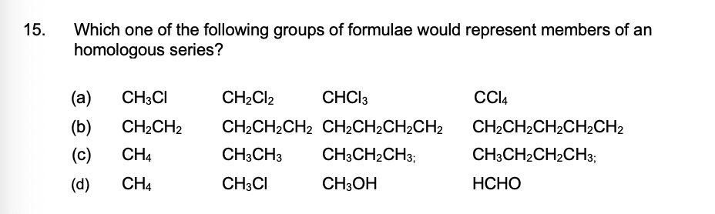

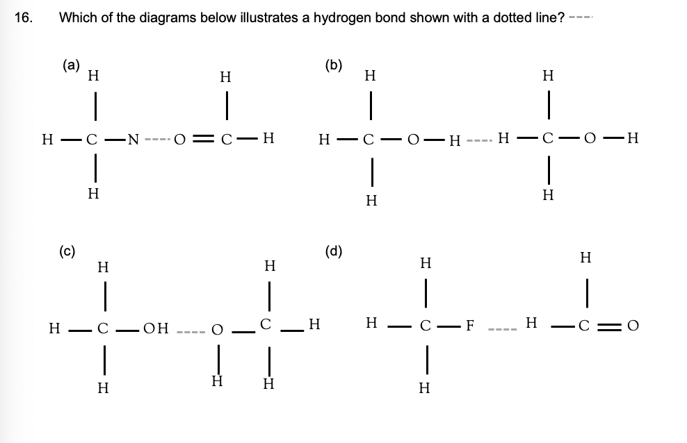

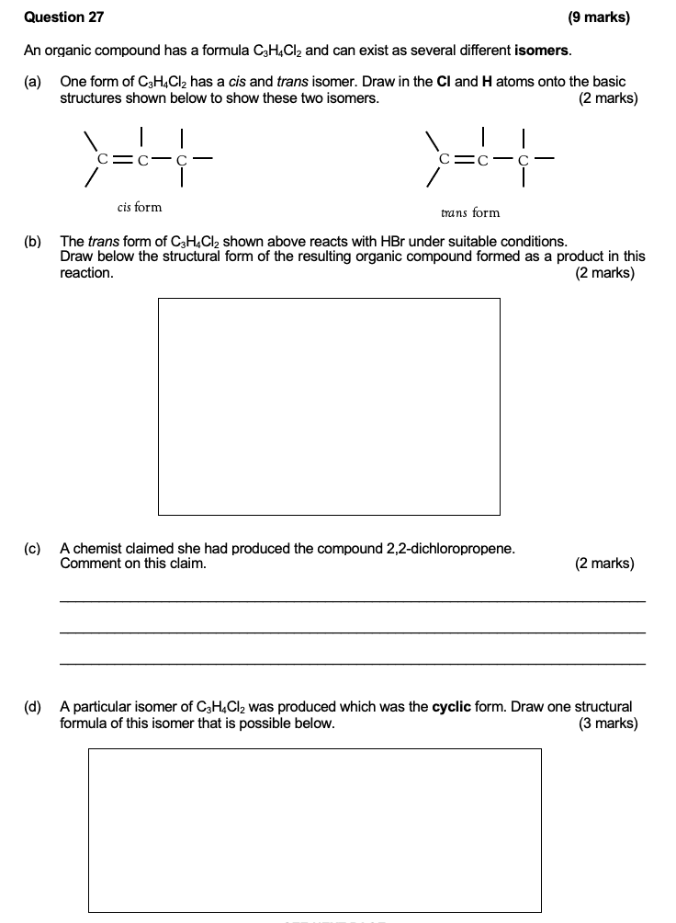

## 2020 S1

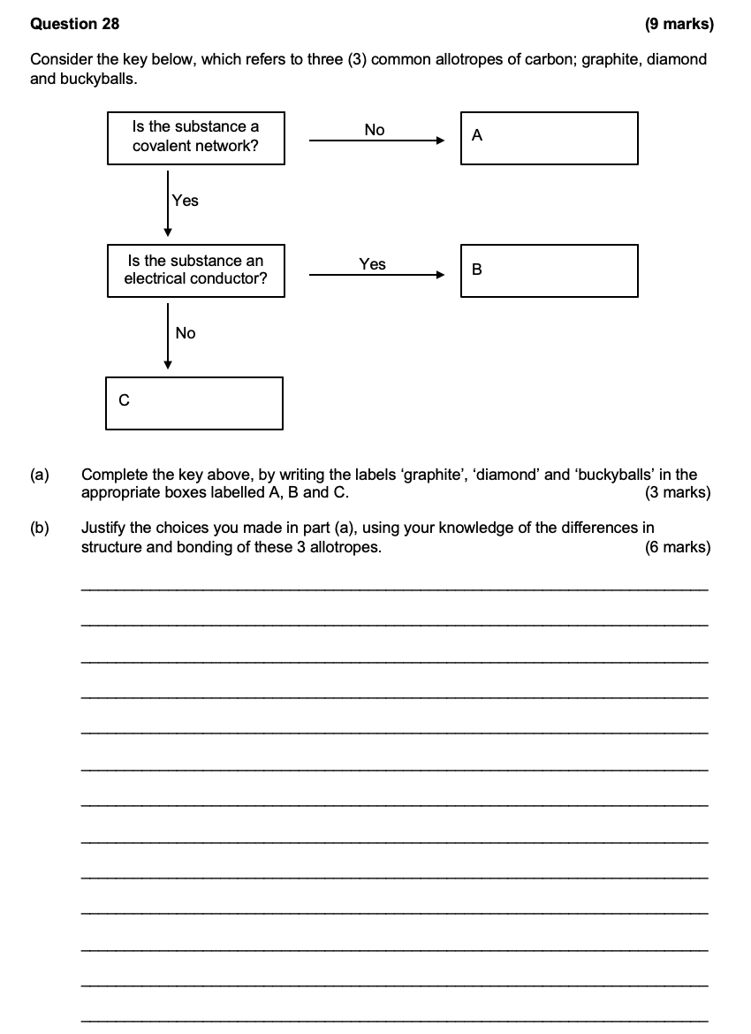

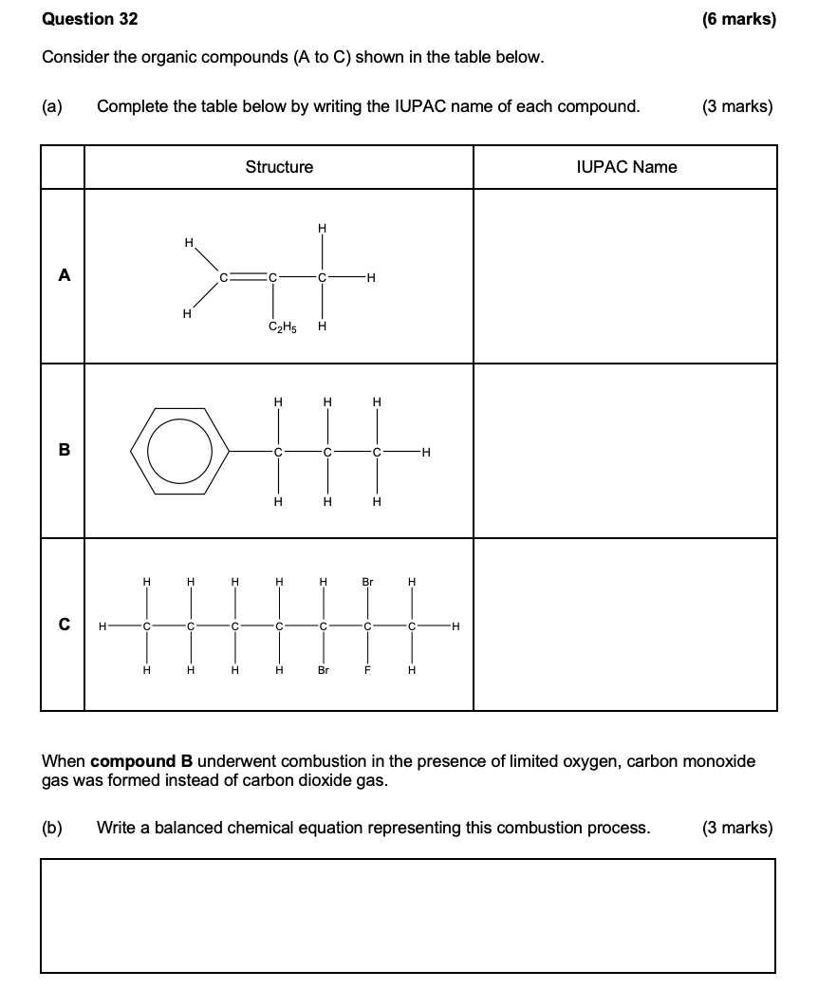

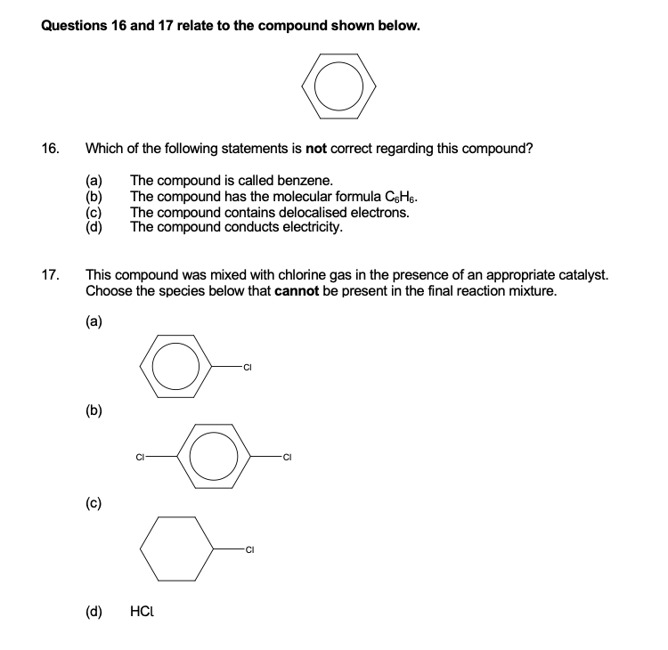

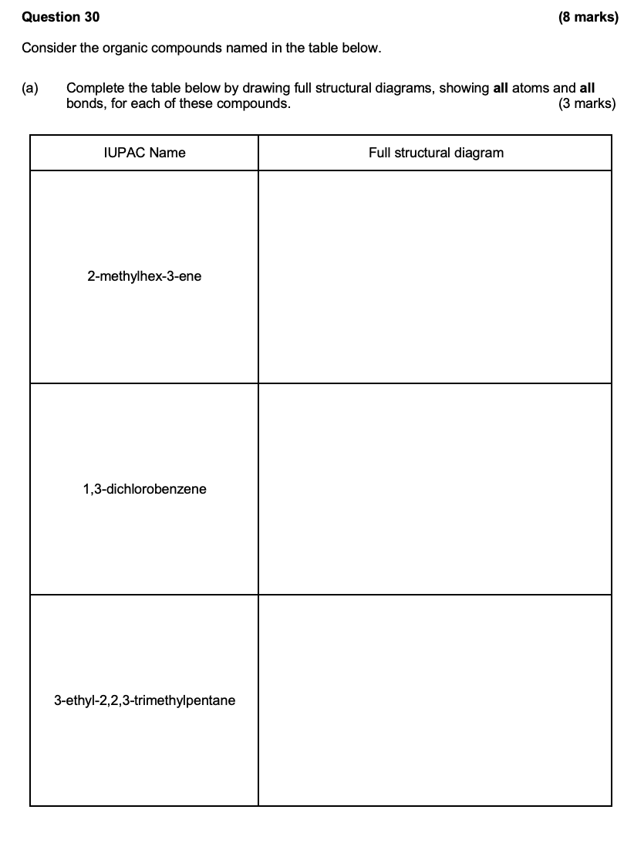

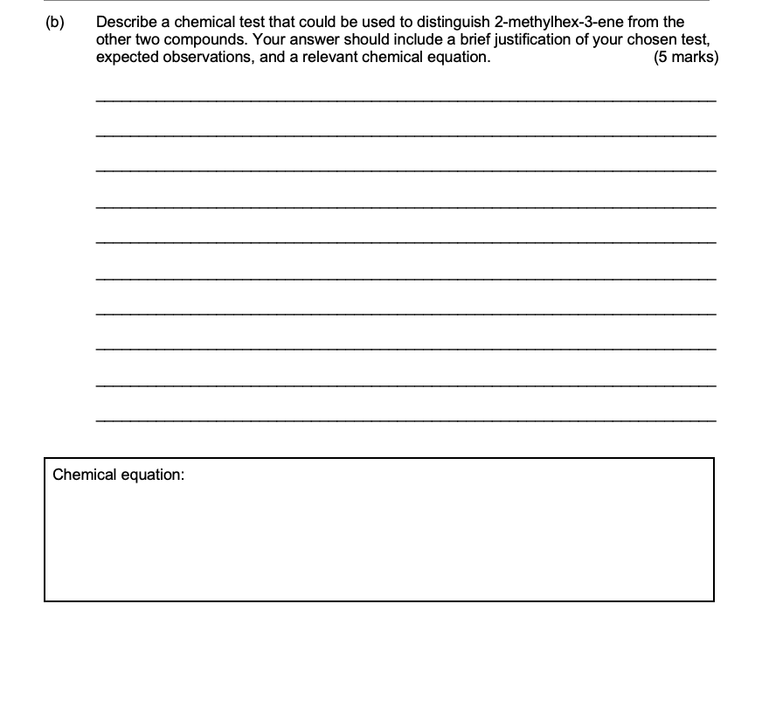

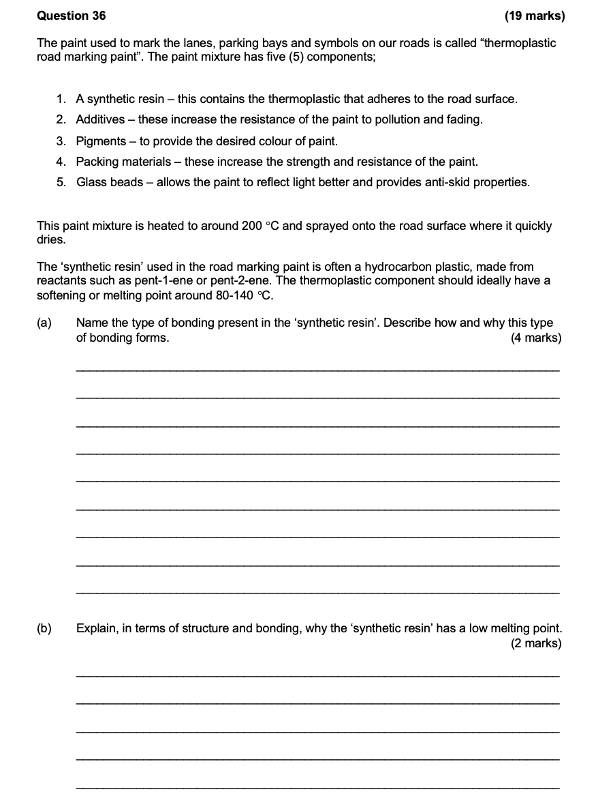

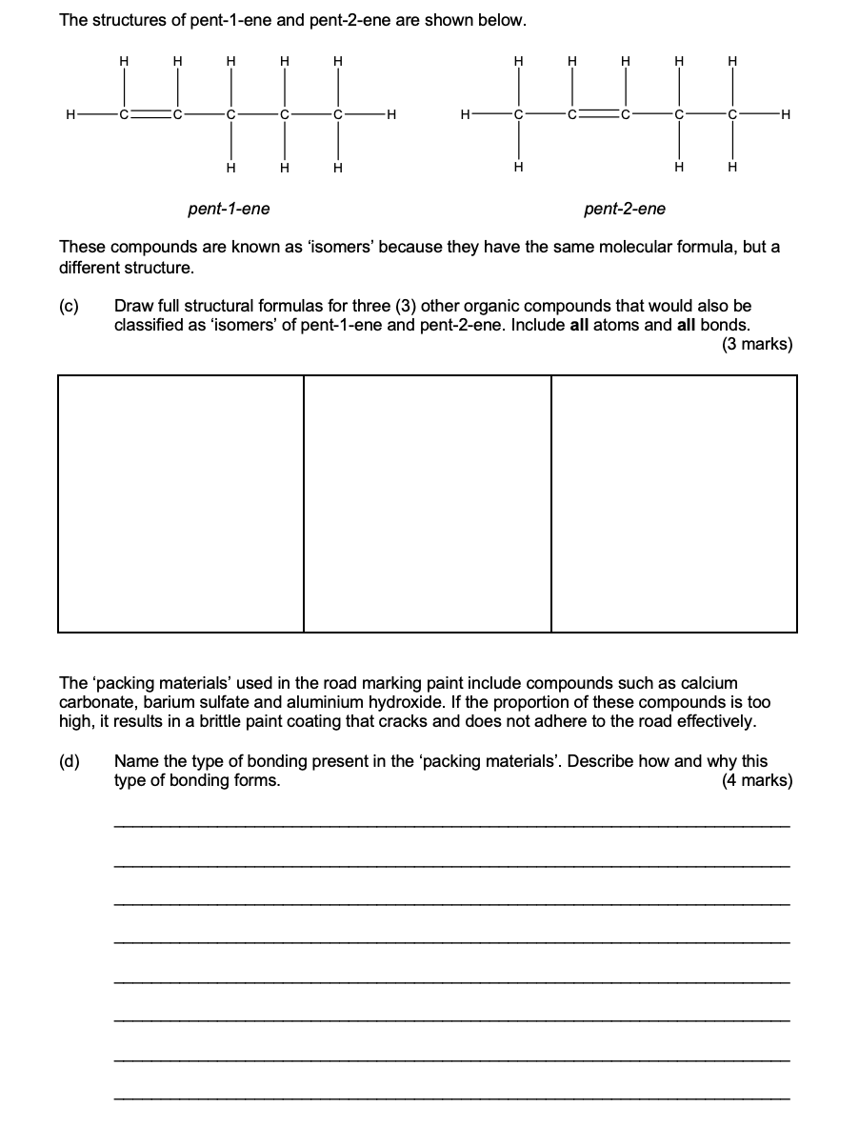

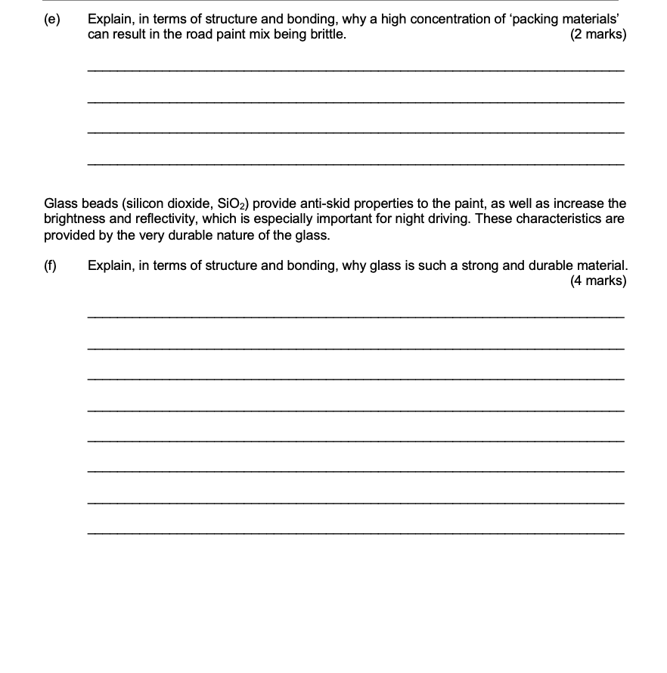

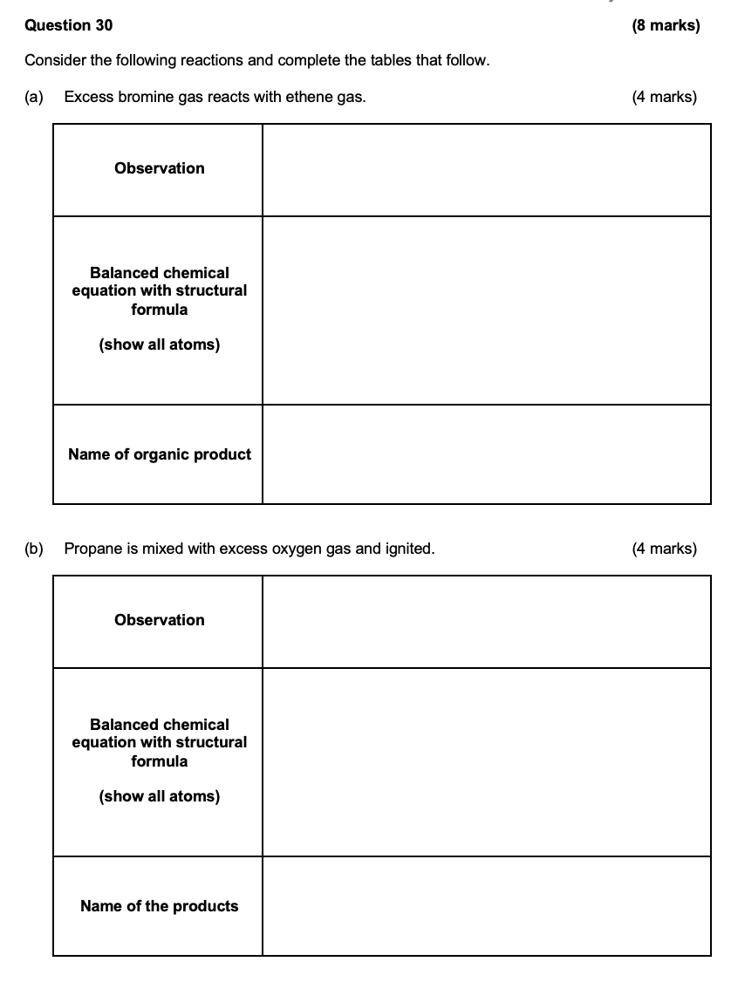

## 2020 S2

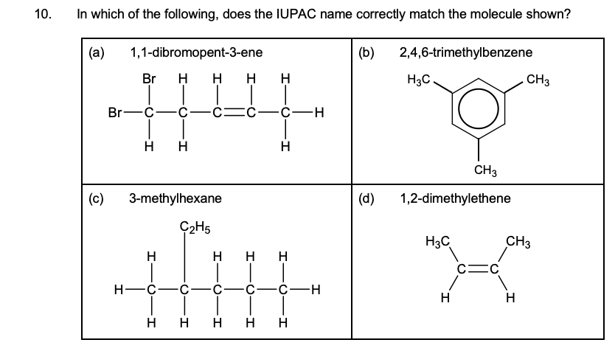

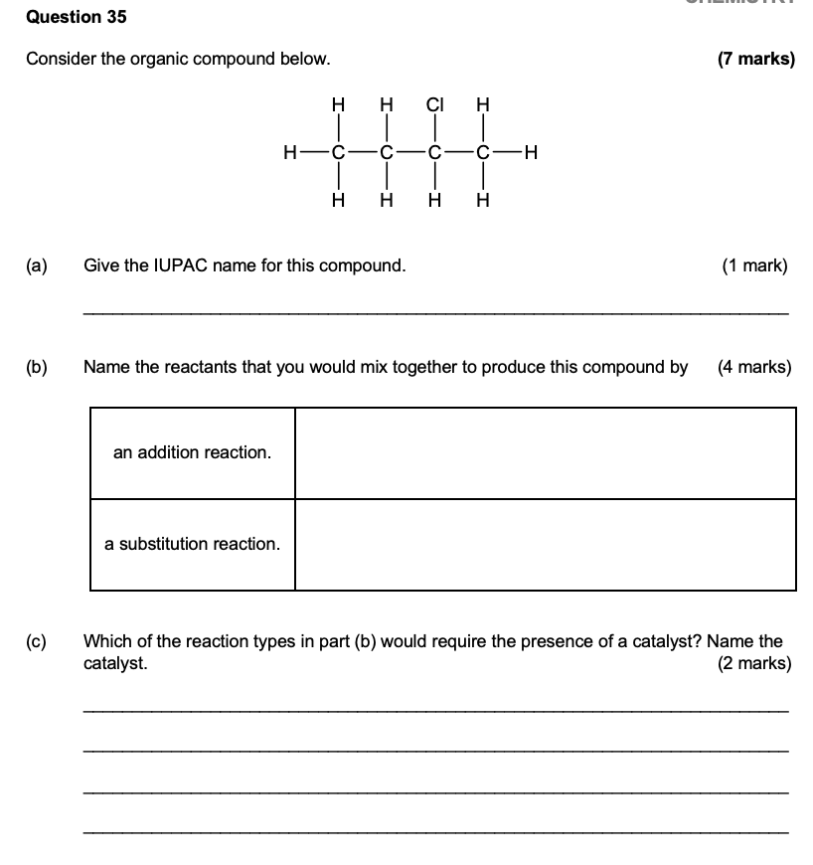

## 2023 S1

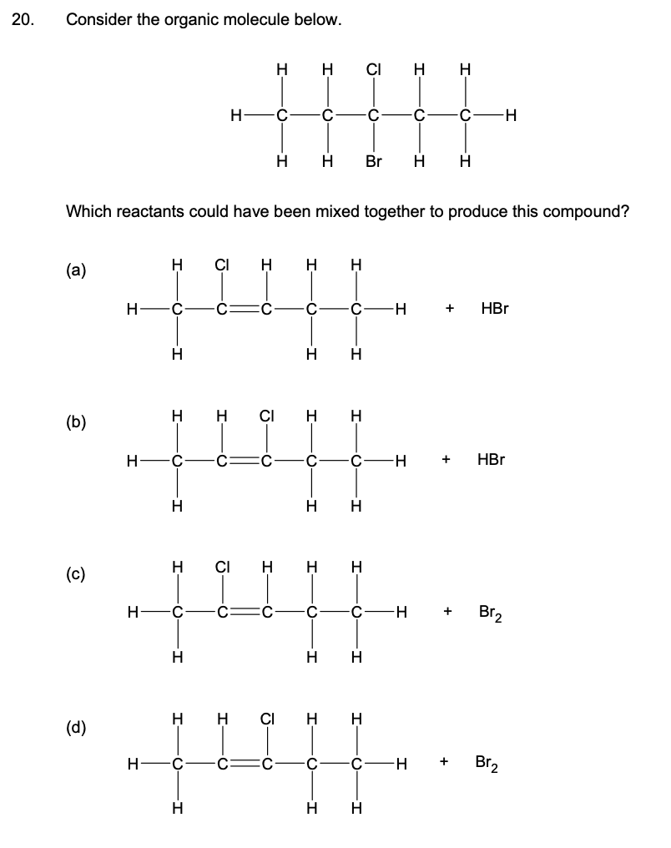

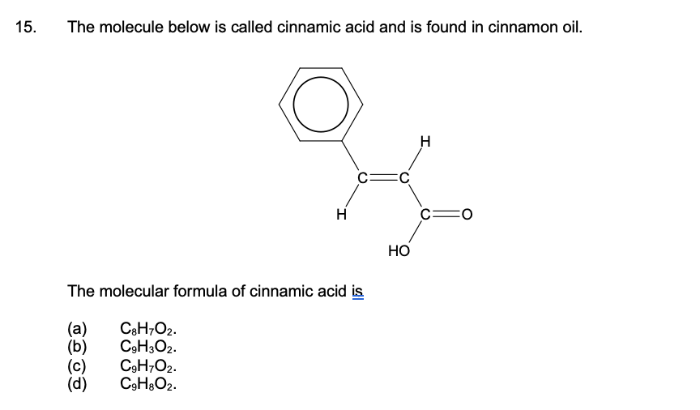

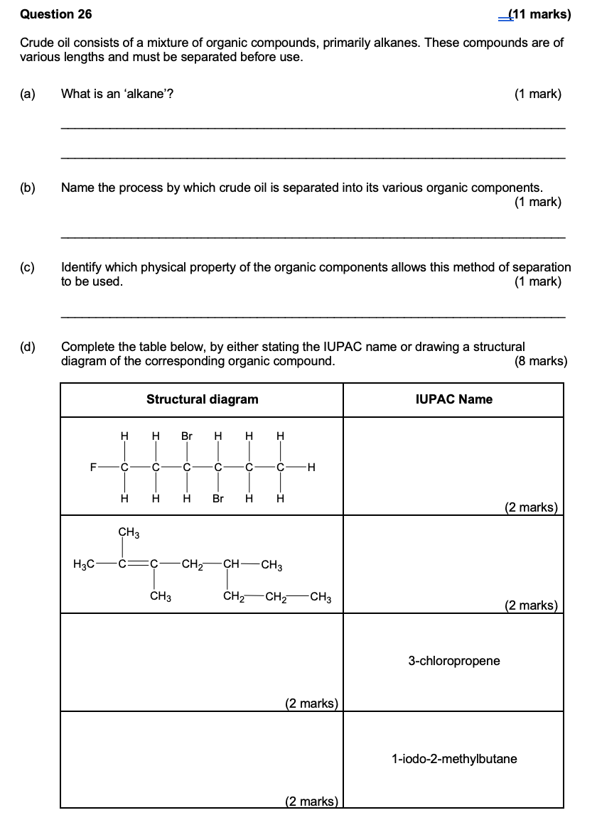

## 2023 S2

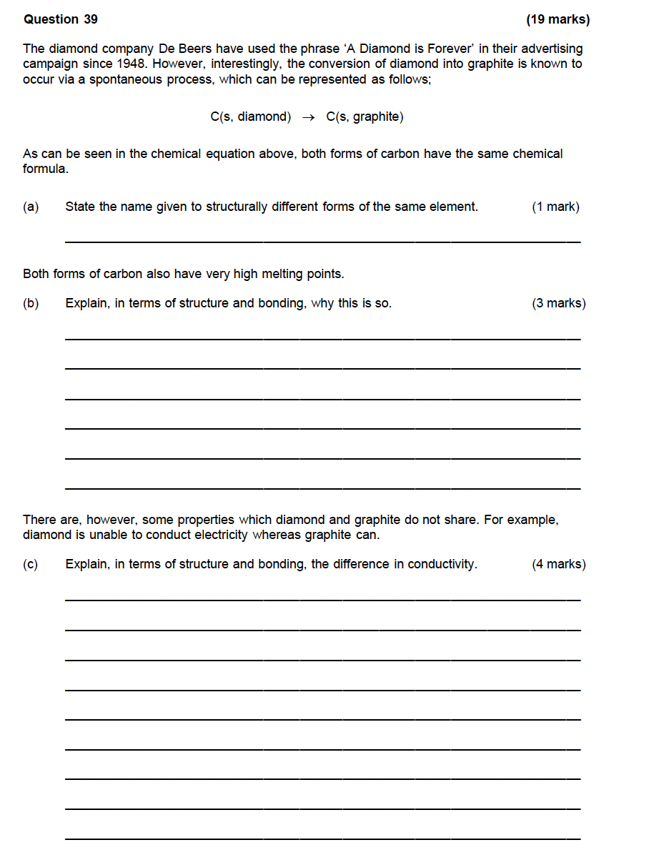

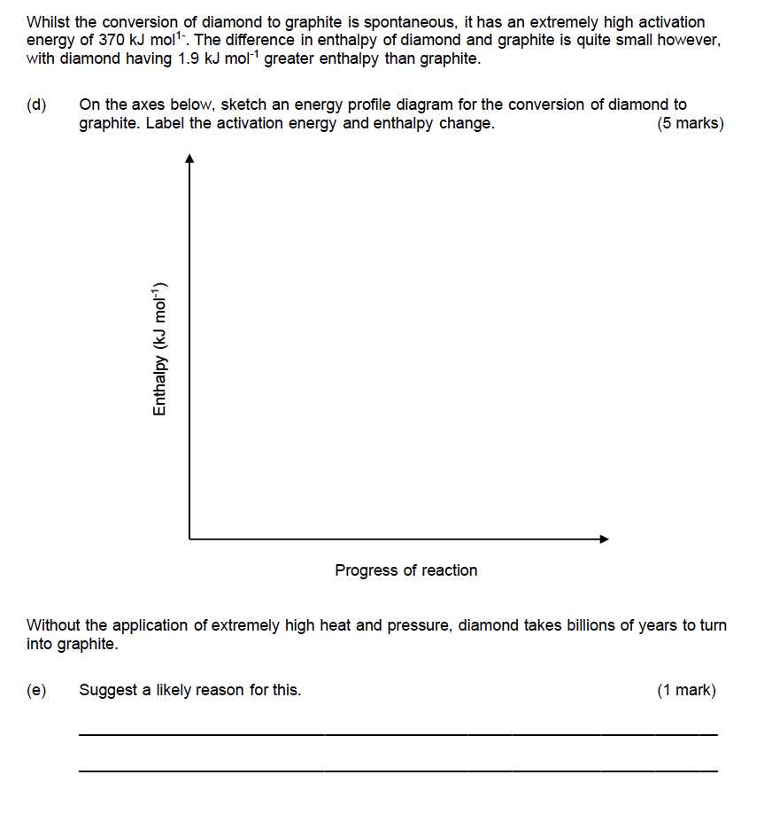

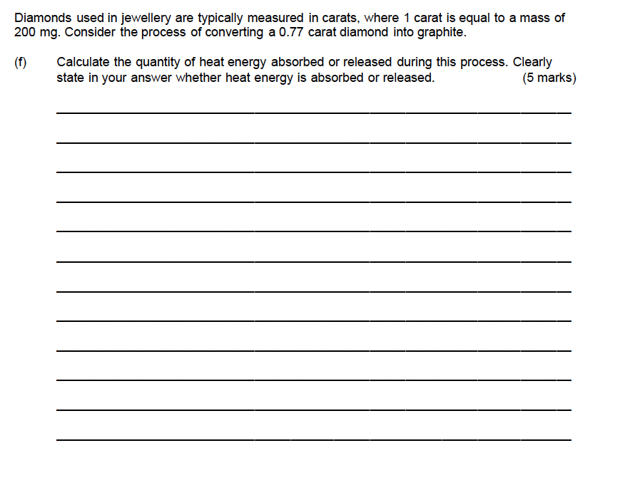

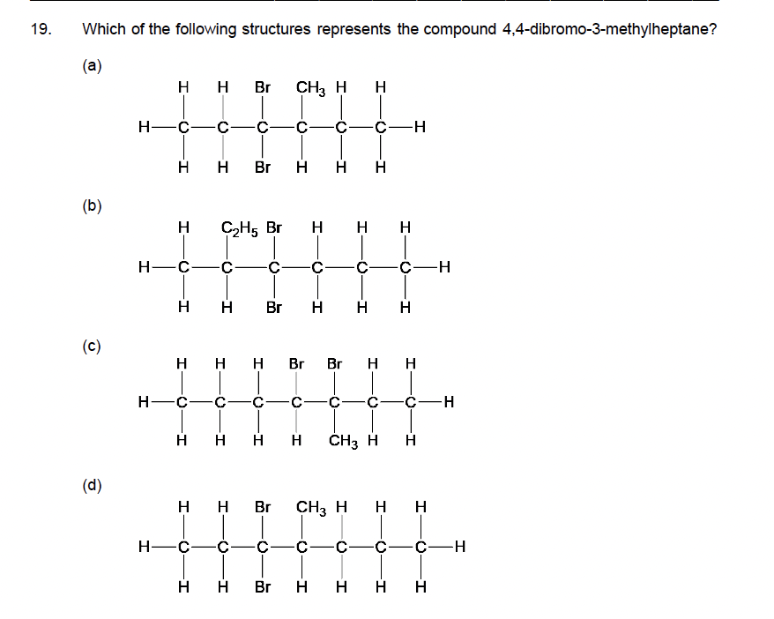

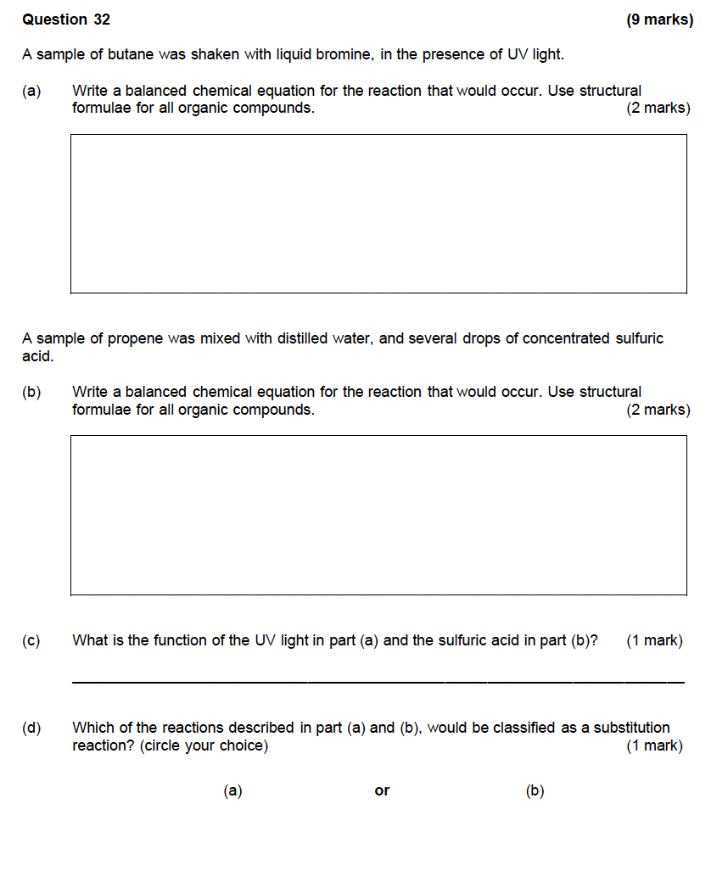

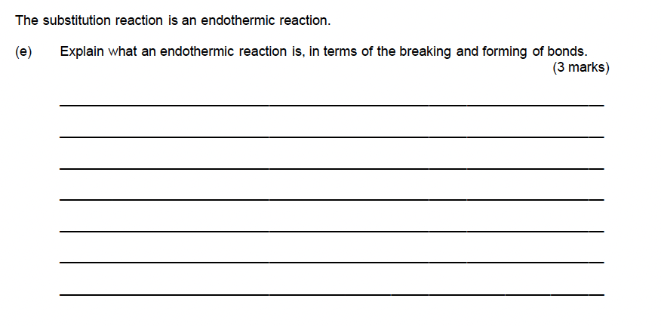

# Nanomaterials – 1.2

## 2017 S1

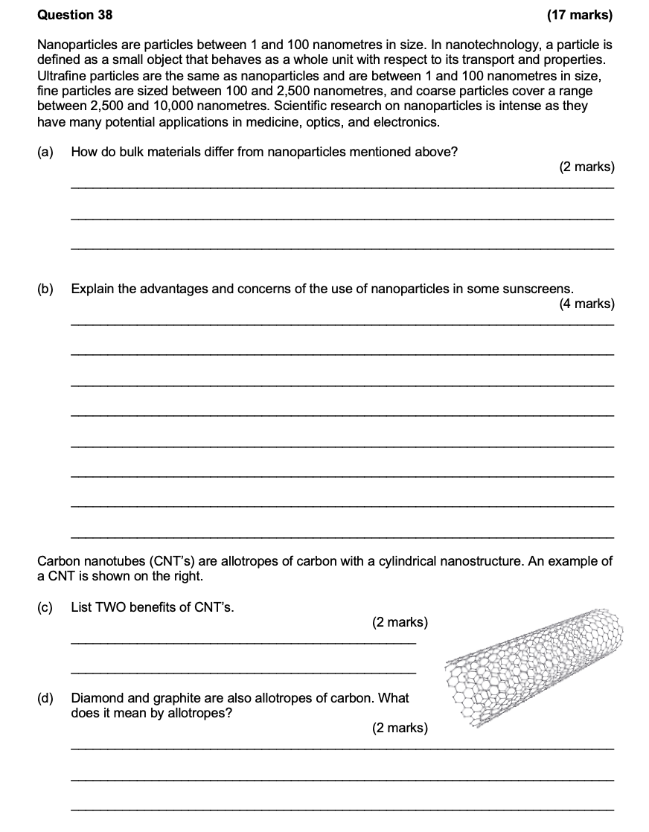

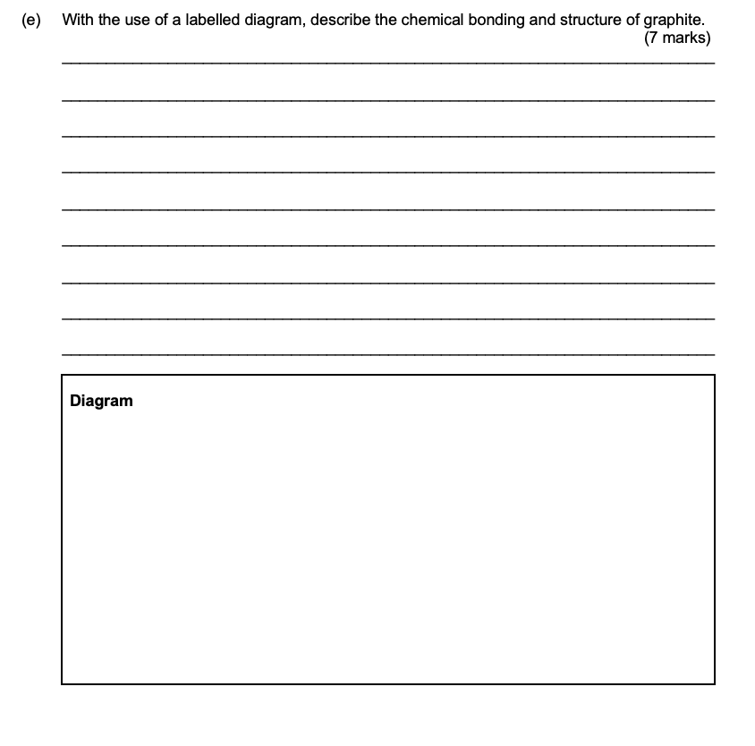

## 2017 S2

## 2020 S1

## 2020 S2

## 2023 S1

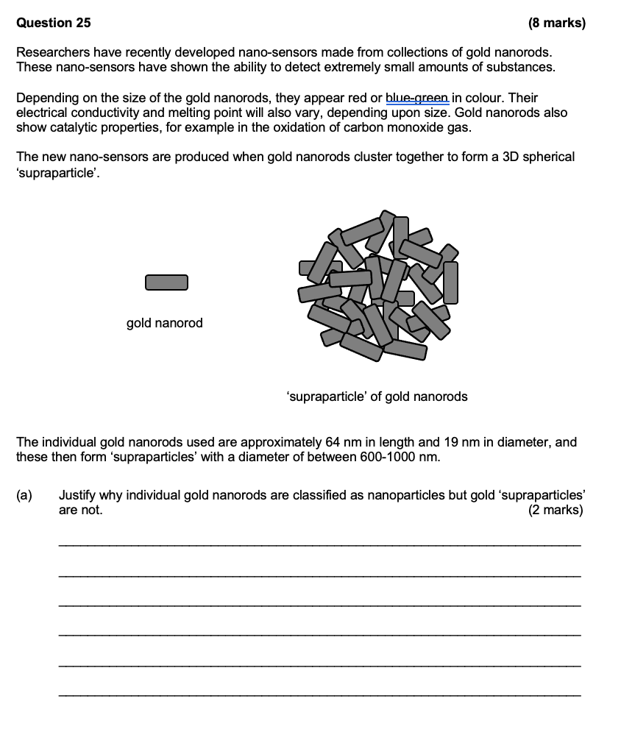

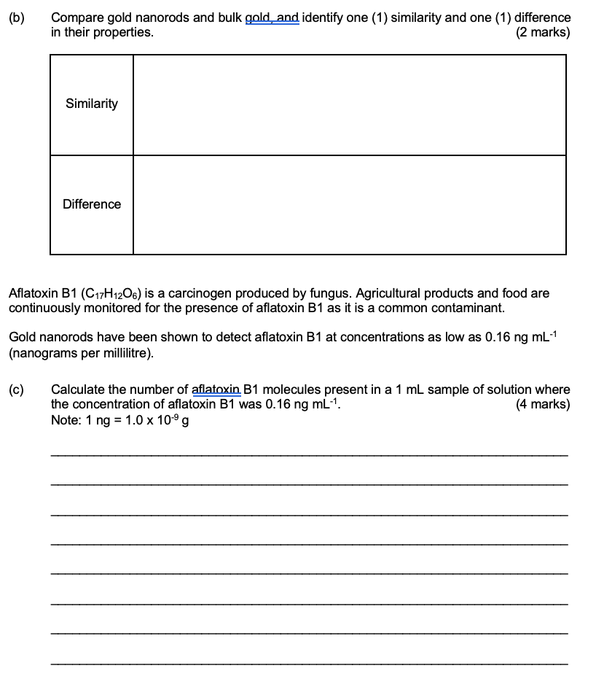

## 2023 S2

## 

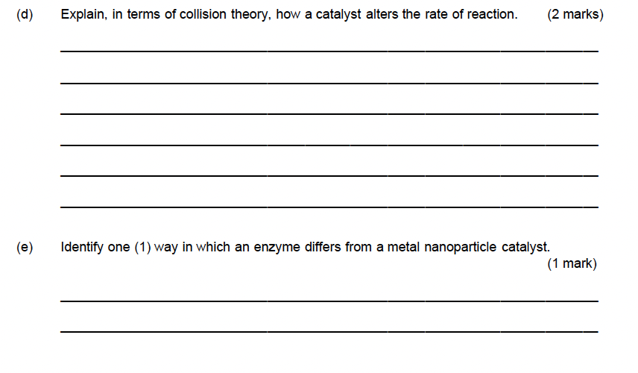

# Other Materials and Separation Techniques – 1.1, 1.3

## 2017 S1

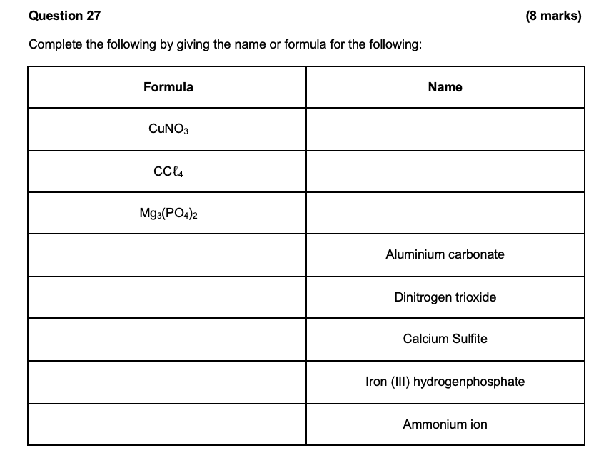

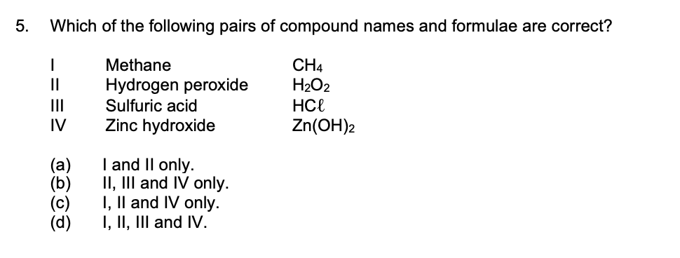

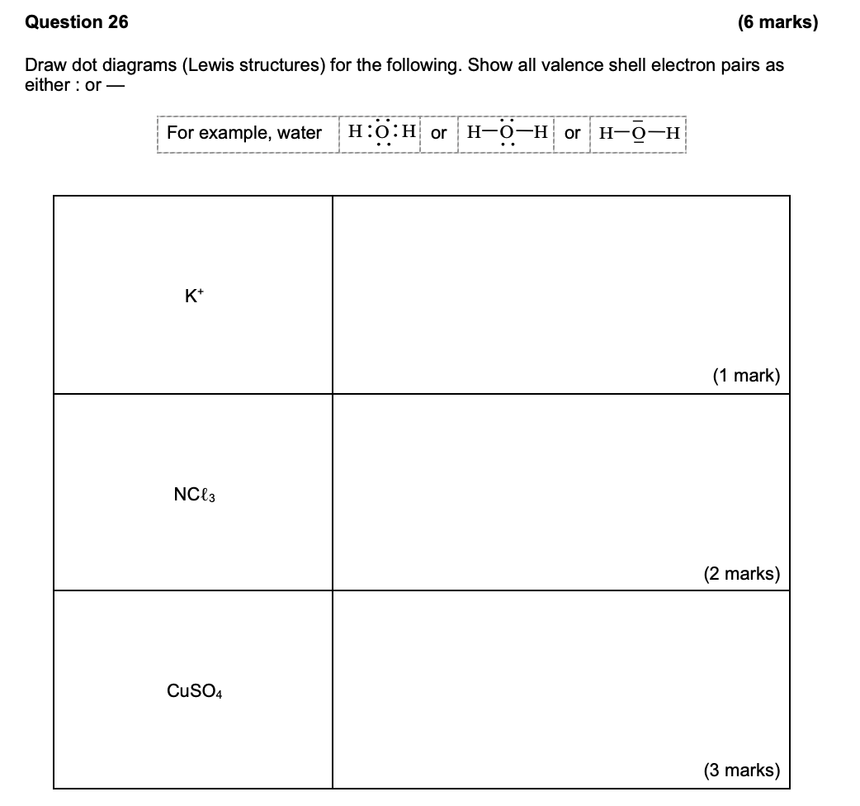

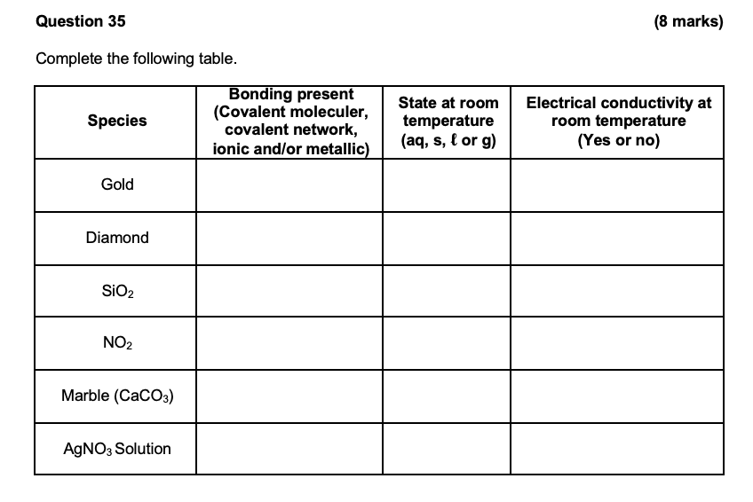

## 2017 S2

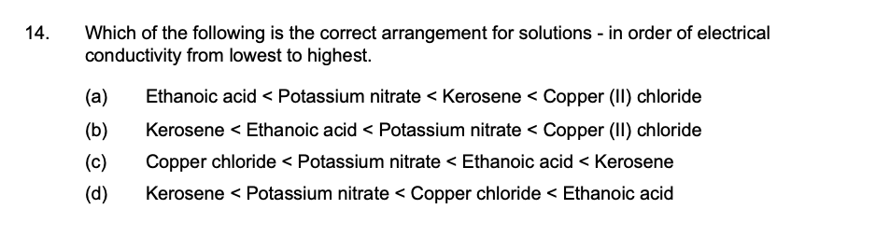

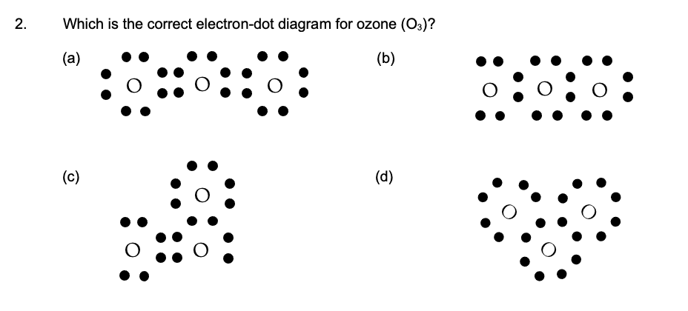

## 2020 S1

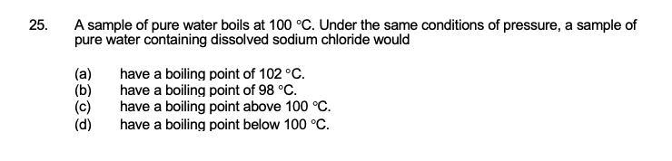

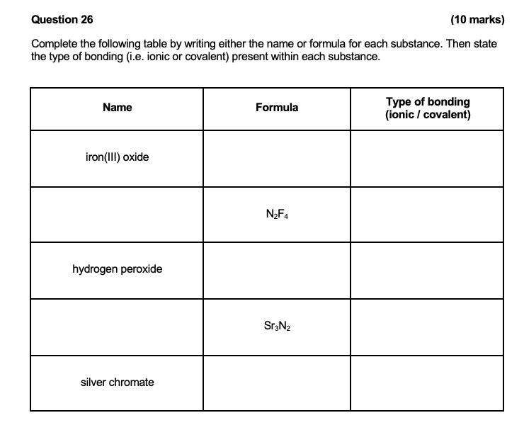

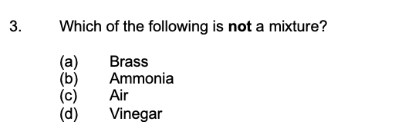

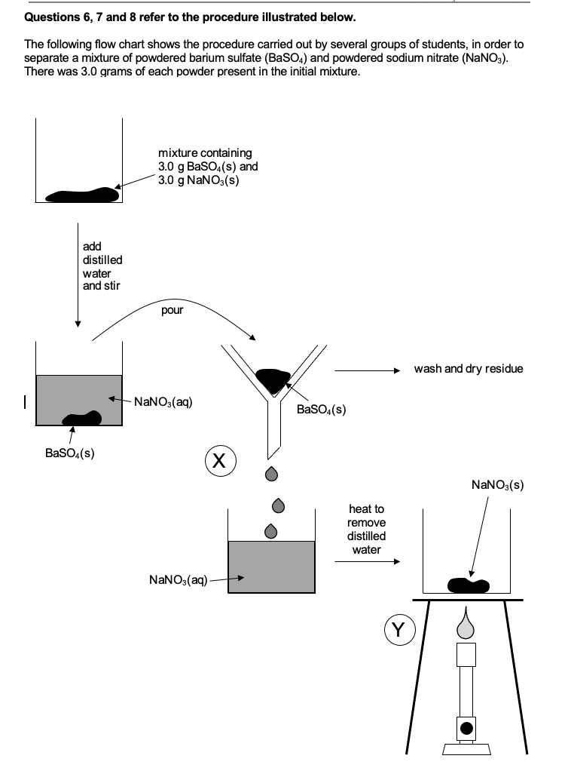

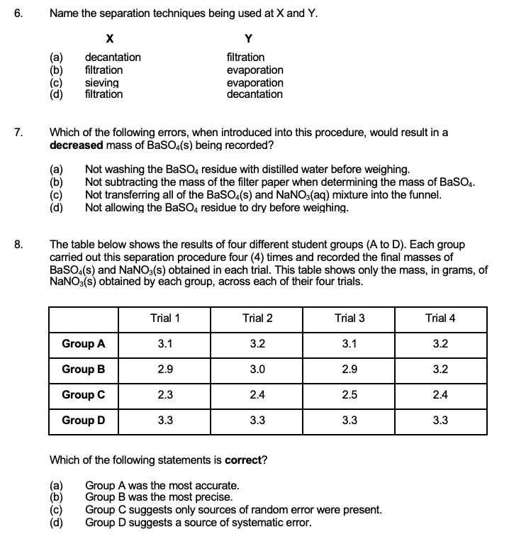

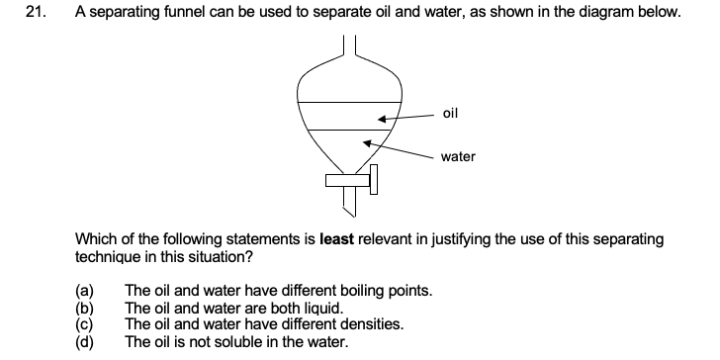

## 2020 S2

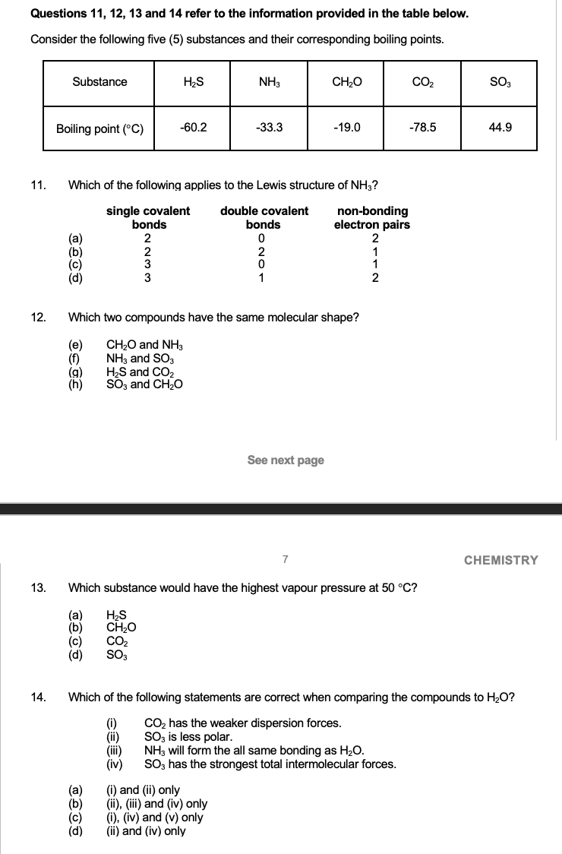

## 2023 S1

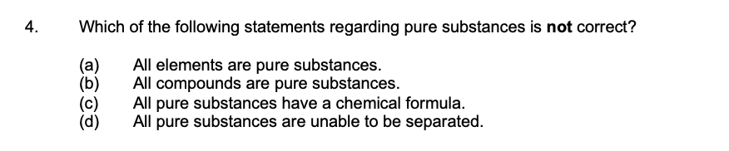

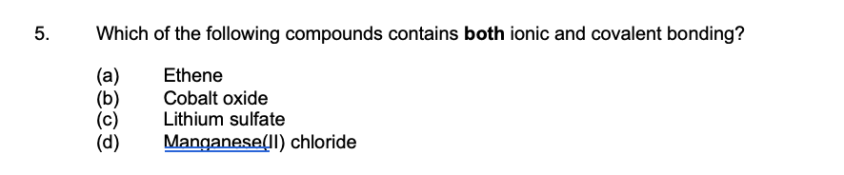

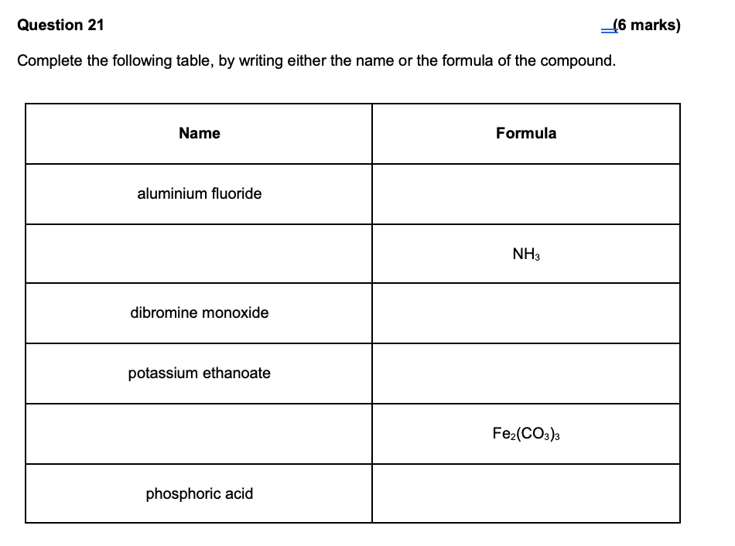

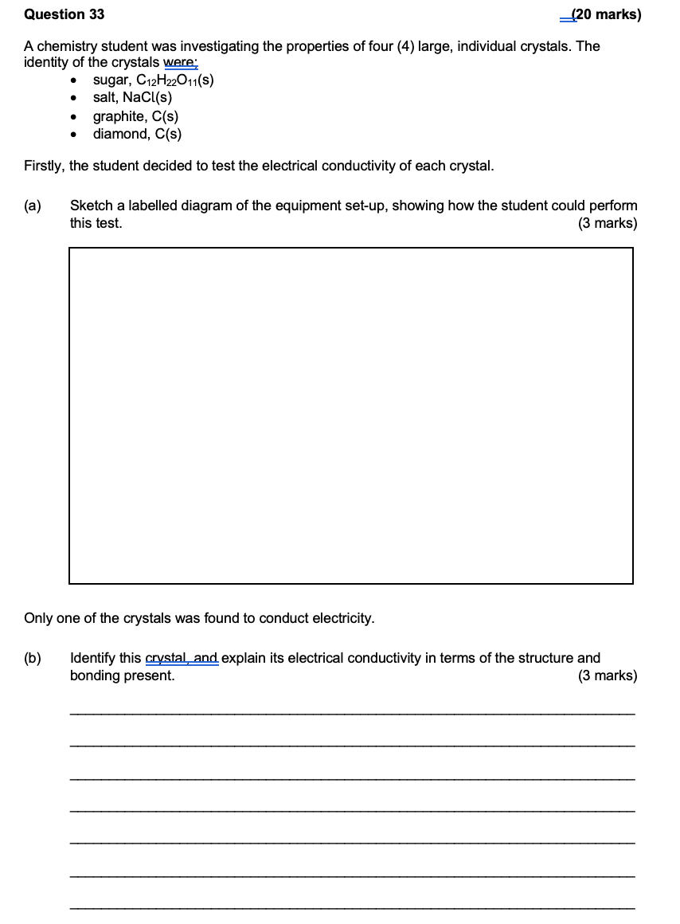

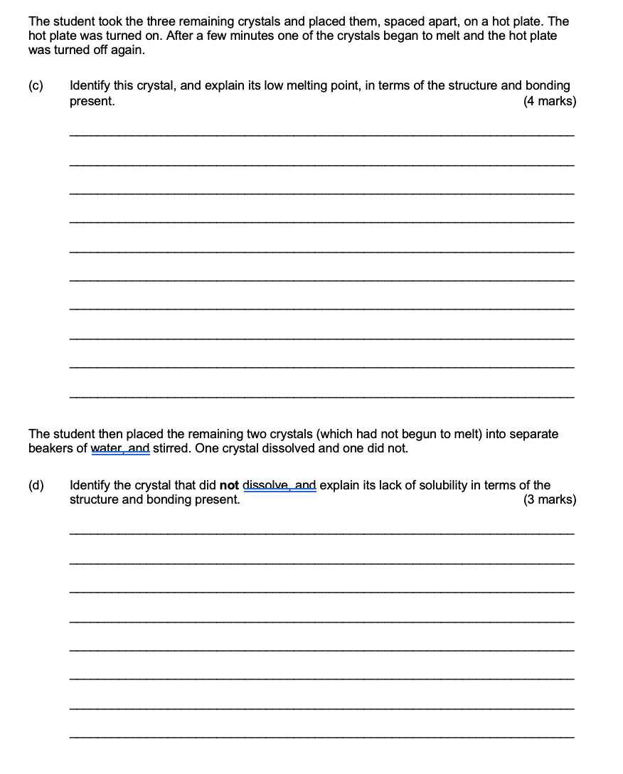

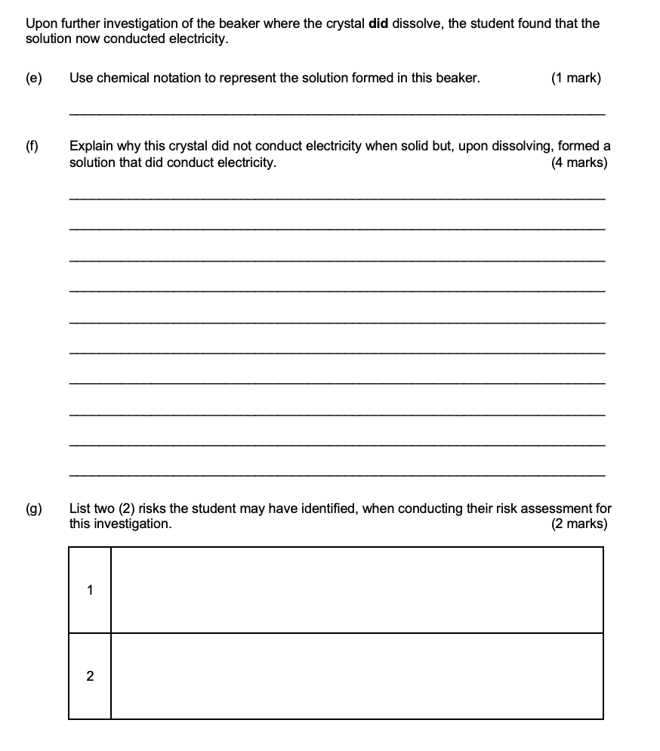

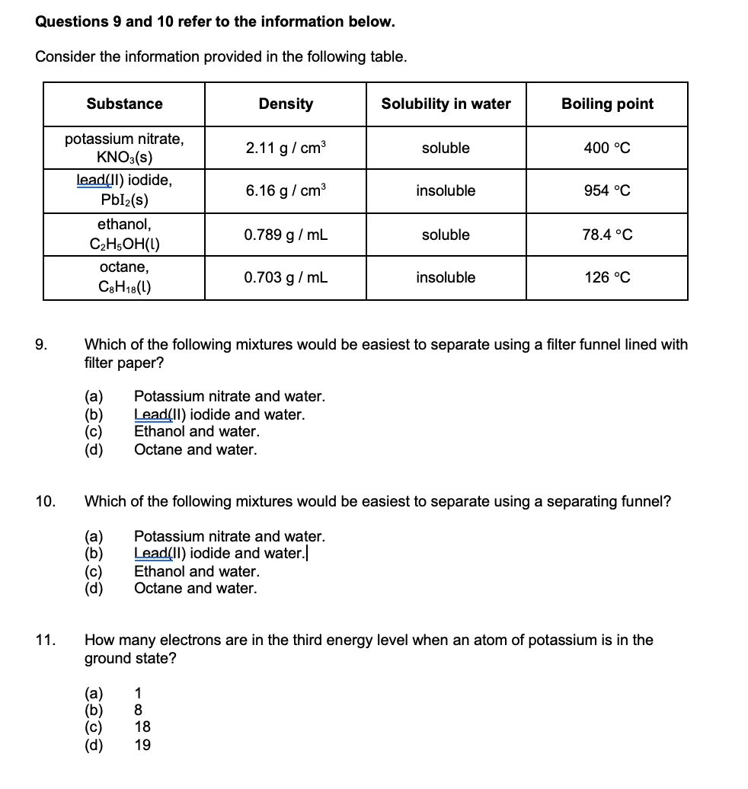

## 2023 S2

## 